Do you have Difficulty Sleeping?

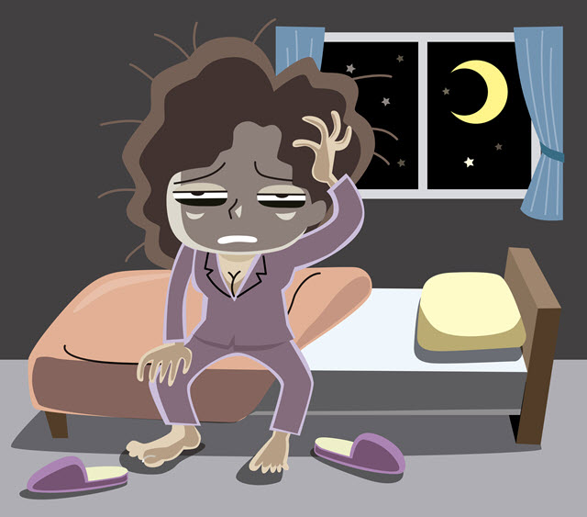
Puget Sound Psychiatric Center (PSPC) is conducting a study to compare the effectiveness of techniques for improving sleep for adults with

Insomnia

You may be eligible if you have a predominant complaint of dissatisfaction with sleep quantity or quality associated with
- Difficulty initiating sleep (takes more than 30 minutes),
- Difficulty maintain sleep, with frequent awakenings or difficulty returning to sleep after awakenings, or
- Early morning awakenings with inability to return to sleep
________________________________________________________________

If you participate in the study, you will receive
6 weeks of free treatment
If you are interested or have questions call (425) 806-5021

Improved Sleep is Possible

PSPC max@pspc.org (425)806-5021
PSPC max@pspc.org (425)806-5021
PSPC max@pspc.org (425)806-5021
PSPC max@pspc.org (425)806-5021
PSPC max@pspc.org (425)806-5021
PSPC max@pspc.org (425)806-5021
PSPC max@pspc.org (425)806-5021
PSPC max@pspc.org (425)806-5021
PSPC max@pspc.org (425)806-5021
PSPC max@pspc.org (425)806-5021
PSPC max@pspc.org (425)806-5021
PSPC max@pspc.org (425)806-5021
PSPC max@pspc.org (425)806-5021
PSPC max@pspc.org (425)806-5021
PSPC max@pspc.org (425)806-5021

